ISO/DIS 29481-1:2024(en)
ISO/TC 59/SC 13
Secretariat: SN
Date: 2025-02-19
Building information models — Information delivery manual — Part 1: Methodology and format

© ISO 2024
All rights reserved. Unless otherwise specified, or required in the context of its implementation, no part of this publication may be reproduced or utilized otherwise in any form or by any means, electronic or mechanical, including photocopying, or posting on the internet or an intranet, without prior written permission. Permission can be requested from either ISO at the address below or ISO's member body in the country of the requester.
ISO Copyright Office
CP 401 • CH-1214 Vernier, Geneva
Phone: + 41 22 749 01 11
Email: copyright@iso.org
Website: www.iso.org
Published in Switzerland.
Contents Page
Foreword vi
Introduction vii
Figure 1 — Relationships between ISO 29481-1 and other relevant standards viii
1 Scope 1
2 Normative references 1
3 Terms and definitions 1
3.1 General 1
3.2 Information organization and management 2
3.3 Information delivery 3
3.4 Interaction within organizations 4
4 Information delivery manual 5
4.1 General 5
4.2 General requirements of an IDM 5
4.3 Users of this document 5
4.4 Use case 6
4.5 Business context 6
4.5.1 General 6
Figure 2 — Example of a simple business context requiring an IDM 7
4.5.2 Process maps 7
4.5.3 Interaction maps 8
4.6 Exchange requirements 9
4.7 Information delivery 9
5 IDM framework 9
5.1 General 9
Figure 3 — IDM basic framework 10
5.2 Common metadata for all IDM components 10
5.3 Use case specification 11
5.3.1 General 11
Figure 4 — Typical components of a use case 11
5.3.2 Standard project phases 11
Table 1 — Project phases in ISO 22263:2008 11
5.3.3 Local project phases 12
5.4 Business context 12
5.5 Exchange requirement 13
5.5.1 General 13
5.5.2 Information units 13
5.5.3 Information constraints 13
6 Aspects of technical implementation 14
6.1 General 14
6.2 Interaction framework 14
6.3 Exchange view definition 14
Annex A (informative) IDM development guidelines 16
A.1 Propose an IDM development 16
A.1.1 General information 16
A.1.2 Define scope 16
A.1.3 Establish the development approach 16
A.1.4 Identify resources 16
A.1.5 Activity schedule 17
A.2 Undertake an IDM development 17
A.2.1 Overview 17
Figure A.1 — IDM development process 17
A.2.2 Discover a use case 17
A.2.3 Specify business contexts 18
Figure A.3 — BC specification process 18
A.2.4 Create exchange requirement 18
Figure A.4 — ER derivation process 19
A.2.5 Reverse engineering 19
A.2.6 EVD development process 19
Figure A.5 — EVD development process 19
A.2.7 Validation and use of IDMs 20
Annex B (informative) A Simplified Example of an IDM Document 21
B.1 General 21
Annex C (informative) IDM use of BPMN methods 22
C.1 General information 22
Figure C.1 — Recommended subset of BPMN symbols for process map development 22
Table C.1 — Definitions of the recommended subset of BPMN symbols 22
C.2 Specification of flows 24
C.3 Specification of events 25
C.4 Specification of data objects 25
C.5 Specification of exchange requirements within a process map 26
Annex D (informative) IDM use of interaction map symbols 27
D.1 General information 27
Figure D.1 — Legend of an interaction map 28
Table D.1 — Definitions of the recommended subset of DEMO symbols 28
D.2 Specification of transactions and roles 29
Figure D.2 — SOI as composite actor role and border transaction 30
Figure D.3 — External actor role with initiator link to border transaction 30
Figure D.4 — External actor role with unveiled SOI 31
Figure D.5 — Interaction map with all roles linked to transactions 31
D.3 Validating the model 31
D.4 Creating a sequence diagram of a transaction 32
Figure D.6 — Example of a sequence diagram of a transaction 32
Bibliography 33

Foreword
ISO (the International Organization for Standardization) is a worldwide federation of national standards bodies (ISO member bodies). The work of preparing International Standards is normally carried out through ISO technical committees. Each member body interested in a subject for which a technical committee has been established has the right to be represented on that committee. International organizations, governmental and non-governmental, in liaison with ISO, also take part in the work. ISO collaborates closely with the International Electrotechnical Commission (IEC) on all matters of electrotechnical standardization.
The procedures used to develop this document and those intended for its further maintenance are described in the ISO/IEC Directives, Part 1. In particular the different approval criteria needed for the different types of ISO documents should be noted. This document was drafted in accordance with the editorial rules of the ISO/IEC Directives, Part 2 (see www.iso.org/directives).
ISO draws attention to the possibility that the implementation of this document may involve the use of (a) patent(s). ISO takes no position concerning the evidence, validity or applicability of any claimed patent rights in respect thereof. As of the date of publication of this document, ISO had not received notice of (a) patent(s) which may be required to implement this document. However, implementers are cautioned that this may not represent the latest information, which may be obtained from the patent database available at www.iso.org/patents. ISO shall not be held responsible for identifying any or all such patent rights.
Any trade name used in this document is information given for the convenience of users and does not constitute an endorsement.
For an explanation of the voluntary nature of standards, the meaning of ISO specific terms and expressions related to conformity assessment, as well as information about ISO's adherence to the World Trade Organization (WTO) principles in the Technical Barriers to Trade (TBT), see www.iso.org/iso/foreword.html.
This document was prepared by Technical Committee ISO/TC 59, Buildings and civil engineering works, Subcommittee SC 13, Organization and digitization of information about buildings and civil engineering works, including building information modelling (BIM), in collaboration with the European Committee for Standardization (CEN) Technical Committee CEN/TC 442, Building Information Modelling (BIM), in accordance with the Agreement on technical cooperation between ISO and CEN (Vienna Agreement).
This third edition cancels and replaces the second edition (ISO 29481-1:2016), which has been technically revised.
The main changes are as follows:
— updated the text to cover infrastructure assets as well as buildings;
— aligned terminology with other related standards;
— significantly revised the text and annexes to improve readability and clarity of meaning.
A list of all parts in the ISO 29481 series can be found on the ISO website.
Any feedback or questions on this document should be directed to the user’s national standards body. A complete listing of these bodies can be found at www.iso.org/members.html.

Introduction
This document specifies the format used to present the exchange requirements for a use case and its associated business processes. This is referred to as an information delivery manual (IDM) since it precisely defines the “information delivery” requirements of the use case, recording those using natural language in a “manual” that can be understood by all stakeholders. An IDM consists of three components: the use case description, the business context and specified exchange requirements.
IDMs can be used to solve commonplace problems associated with communication between different parties in project teams or asset management teams by ensuring the clarity of and responsibility for information. An IDM helps all parties get the full benefits from any information model by understanding how the information will be used. If the required information is delivered in a reliable format to support different purposes across the life of an asset and the quality of the information is satisfactory, then the use cases and associated business processes will be greatly improved.
This document provides a methodology that begins by identifying a use case, then defines the business context and its associated business processes using recommended mapping techniques to finally arrive at a detailed specification of the required exchange requirements between parties at specific times during those business processes.
This IDM methodology has been developed specifically for the built environment sector concerned with all aspects of the delivery and management of assets. These activities can be both contractual (such as asset delivery) and non-contractual (such as regulatory compliance) between all stakeholders within the built environment sector and across the whole asset life cycle.
IDM development can be streamlined in various ways as described in Annex A. This document also includes a brief overview of technical implementations of IDMs to support solutions provided by software developers, and how an IDM can be configured to meet national, local and project needs.
It is often assumed that information delivery would be achieved using an information model – represented using industry foundation classes (IFC) – and conforming to an information delivery specification to satisfy the exchange requirements. This document significantly broadens that assumption to include any information formats that can satisfy (in whole or in part) the exchange requirements for a given business process.
Additional standards have been published in support of information management and building information modelling. Figure 1 shows the position of this document within the context of these other standards.
The ISO 19650 series set out general concepts and principles for information management throughout the whole asset life cycle, as well as specific requirements to manage information during project delivery or asset management. It also specifies an approach for achieving information security in a collaborative working environment and sets out criteria to be used to assess the quality of information deliverables.
The ISO 19650 series and the ISO 29481 series use the same terminology wherever possible. The IDM specification in this document is the appropriate way to record the relationships between types of actors that fulfil the party roles named in the ISO 19650 series and sets out the detailed information that one type of organization requires from another.
The exchange requirements defined in an IDM specify in detail the information that is required but does this in terms of generic actor types (e.g. what a client requires from a designer for a given business process). This is different to the exchange information requirement described in the ISO 19650 series: it is specific to a given appointment (e.g. what the client for project XYZ requires from their designer on that project) and the information may be defined in whatever level of detail is deemed appropriate. This means it is possible for one exchange information requirement to correlate to multiple exchange requirements.
The business context established as part of an IDM can also help define the information management resources used in the ISO 19650 series, such as the information standard and the information production methods and procedures. An IDM can be considered as a toolkit for information managers to identify what information should be received or sent, the actors involved, how that information flows, for what purpose and the milestones for pre-defined use cases.
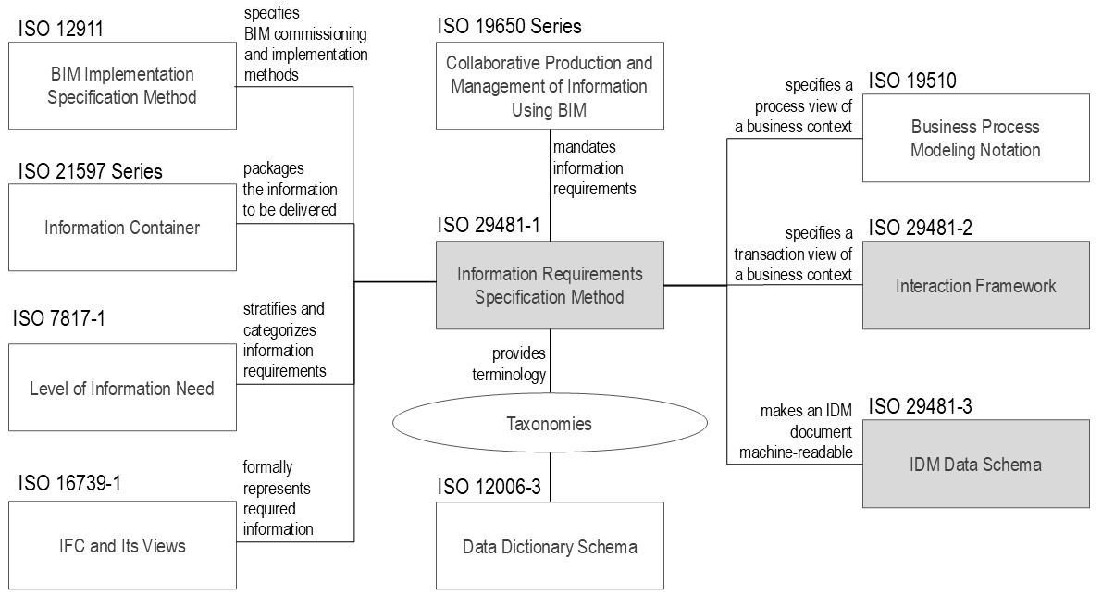

Figure 1 — Relationships between ISO 29481-1 and other relevant standards
Working anticlockwise from the top-left in Figure 1, ISO 12911 defines a systematic approach for developing information management documents as structured specifications to support the automated checking of expected outcomes. The IDM specification in this document can be used to provide content for ISO 12911.
The ISO 21597 series specify the use of linked data techniques to create a collection of structured information models and associated datasets with explicit relationship links between elements in the separate documents, all contained in a single archive format. It provides a way of packaging information deliverables in a consolidated container to support information exchange.
ISO 7817-1 provides an overview of the level of information need. This concept is introduced in the ISO 19650 series as the way for a project client or asset owner to indicate the quantity and nature of information expected in response to any given information requirement. Level of information need provides a more comprehensive way of defining information units that form part of the IDM’s exchange requirement.
ISO 16739-1 provides a way to create a semantically precise representation of real-world assets, resulting in a very effective way of delivering information that satisfies the exchange requirements as specified in this document.
ISO 12006-3 provides a specification for a taxonomy in any domain of interest, allowing terms used to denote information units in an IDM to be structured and mapped to other terms.
ISO 29481-3 defines a specification to store, exchange and read IDM specifications that conform to this document in a standardized machine-readable way. ISO 29481-2 and Iso 19510, shown in the top-right corner of Figure 1, specify the two alternative modelling techniques used to represent a business context map that conforms to this document.
In summary, this document provides a basis for reliable information exchange and sharing so that users can be confident that the information they are receiving is accurate and sufficient for the tasks they must perform. The development of this document has been driven by the need for reliability in information exchange between parties in any business context.

Building information models — Information delivery manual — Part 1: Methodology and format

Scope
This document prescribes:
— how to document a use case with an associated business context and exchange requirements;
— a methodology to identify and specify the information exchanges required at identified times during the life cycle of assets.
This document presents the information delivery manual (IDM) in natural language terms to facilitate interoperability between software applications used during all phases of the life cycle of assets (both buildings and infrastructure). It promotes digital collaboration between actors within the identified business context and provides a basis for accurate, reliable, repeatable and high-quality information exchange.
The information delivery manual (IDM) methodology specified in this document can be applied to any information management trigger event to identify the details of the information required to be exchanged.

Normative references
The following documents are referred to in the text in such a way that some or all of their content constitutes requirements of this document. For dated references, only the edition cited applies. For undated references, the latest edition of the referenced document (including any amendments) applies.
ISO 6707-1, Buildings and civil engineering works — Vocabulary — Part 1: General terms

Terms and definitions
For the purposes of this document, the terms and definitions given in ISO 6707-1 and the following apply.
ISO and IEC maintain terminology databases for use in standardization at the following addresses:
— ISO Online browsing platform: available at https://www.iso.org/obp.
— IEC Electropedia: available at https://www.electropedia.org/.

General
3.1.1
actor
person, organization or organizational unit involved in a business process (3.3.4)
Note 1 to entry: Organizational units include, but are not limited to, departments, teams.
3.1.2
role
functions being performed by an actor (3.1.1) at a point in time
Note 1 to entry: The role of an actor is determined by action and outcome and not necessarily by the profession or trade followed by the actor.
3.1.3
asset
item, thing or entity that has potential or actual value to an organization
[SOURCE: ISO 55000:2024, 3.1.1, modified — Notes to entry have been removed.]
3.1.4
metadata
data about data or data elements
[SOURCE: ISO/IEC 2382:2015, 2121505, modified — "possibly including their data descriptions, and data about data ownership, access paths, access rights and data volatility" has been removed; notes to entry have been removed.]
3.1.5
schema
formal description of a data model (3.1.6)
Note 1 to entry: Schema is specified with properties, structure and interrelationships.
[SOURCE: ISO 19101-1:2014, 4.1.34, modified - Word "data" has been added. Note 1 to entry has been added.]
3.1.6
data model
graphical, lexical or combined representation of data
Note 1 to entry: Data model is described with schema (3.1.5).
[SOURCE: ISO/IEC 11179-1:2023, 3.2.24, modified - Words "specifying their properties, structure, and interrelationships" have been removed. Note 1 to entry has been added.]

Information organization and management
3.2.1
information model
set of structured and unstructured information containers (3.2.2)
[SOURCE: ISO 19650-1:2018, 3.3.8]
3.2.2
information container
named persistent set of information retrievable from within a file, system or application storage hierarchy
[SOURCE: ISO 19650-1:2018, 3.3.12, modified — EXAMPLE and notes to entry have been removed.]
3.2.3
exchange view definition
EVD
computer-interpretable representation of one or more data models (3.1.6) or their parts, required to fulfil the exchange requirement (3.3.10)
Note 1 to entry: This term is adopted in this document to avoid confusion. For example, with the concept of a model view definition (MVD) that is currently used specifically in the construction industry to define a view of all or part of a building information model held in IFC as specified in ISO 16739-1.

Information delivery
3.3.1
information delivery manual
IDM
specification of a use case (3.3.2) using business context (3.3.3) maps and exchange requirements (3.3.10)
Note 1 to entry: Use case, context maps, and exchange requirements can be collectively referred to as IDM components.
3.3.2
use case
UC
description of a business context (3.3.3) by defining a sequence of actions performed by one or more roles (3.1.2) to realize a purpose.
Note 1 to entry: A use case specifies the scope of the context.
[SOURCE: ISO 24014-1:2021, 3.36, modified - the word "process" has been changed to "business context", because a use case can encompass several business processes. The word "actor" has been replaced with "role". The phrase "and by the system itself" has been replaced with "to realize a purpose". The note to entry has been added.]
3.3.3
business context
environment in which actors (3.1.1) undertake business processes
Note 1 to entry: Such an environment includes all the roles (3.1.2), activities, and interactions (3.4.2), products and services under the actor's control.
3.3.4
business process
set of interrelated or interacting activities that use inputs to deliver an intended result
EXAMPLE: Agreements, systems, services, or products.
Note 1 to entry: a business process always contains one or more transactions (3.4.2).
[SOURCE: ISO 9000:2015, 3.4.1, modified — EXAMPLE has been added; notes to entry have been replaced with a new note to entry.]
3.3.5
business context map
graphical representation of the information flows related to a context
EXAMPLE: Interaction maps (3.3.7) and process maps (3.3.6).
3.3.6
process map
PM
context map of the activities related to a use case (3.3.2)
3.3.7
interaction map
context map of the interactions (3.4.2) related to a use case (3.3.2)
3.3.8
information exchange
act of satisfying an information requirement (3.3.9) or part thereof
[SOURCE: ISO 7817-1:2024, 3.3, modified — The part of speech "verb" has been removed.]
3.3.9
information requirement
specification for what, when and for whom information is to be produced
Note 1 to entry: The specification of "how information is to be produced" is part of level of information need.
[SOURCE: ISO 19650-1:2018, 3.3.2, modified — The word "how" has been removed; note 1 to entry has been added.]
3.3.10
exchange requirement
ER
defined collection of information units (3.3.11) required to fulfil a use case (3.3.2)
3.3.11
information unit
description of a piece of information
EXAMPLE: Inspection report, window identifier, room depth.
Note 1 to entry: Information units can refer to anything used as part fulfilment of an exchange requirement, ranging from entire information containers such as an "invitation to bid" or an asset model, to specific information items such as the properties of objects or the components that make up an object

Interaction within organizations
3.4.1
interaction framework
XML file for the elements of an interaction (3.4.2)
Note 1 to entry: Elements of an interaction include roles (3.1.2), transactions (3.4.2), messages, and information units (3.3.11).
3.4.2
interaction
communicative action between two roles (3.1.2)
3.4.3
transaction
sequence of interactions (3.4.2) involving the exchange of information using messages
EXAMPLE: Processing of a request by one role (3.1.2) on behalf of another.
Note 1 to entry: A transaction is a message between the initiator and the executor.

Information delivery manual

General
This clause specifies the general requirements of an IDM as well as the concepts and principles that inform the development of its three main components: a defined use case, a description of the business context and the specification of the exchange requirements. The IDM methodology presented in this document may be followed to develop an IDM from first principles, but that work may also be streamlined as described in the Annex A if the prescribed components of the IDM are provided as described in this document and the information specifications are able to be made relevant to local working practices.

General requirements of an IDM
An IDM shall deliver the following as a minimum:
— a description of the use case addressed by the IDM;
— a description of the need for information exchange within the business context;
— the identity of the actors involved in any information exchange;
— a definition and description of the activities or interactions where information is created, used or exchanged between actors to deliver a service or produce an end product;
— definitions, specifications and descriptions that are able to be understood;
— detailed specifications of exchange requirements including the identification of relevant objects within structured information containers.
Further details for specifying an IDM are given in Clause 5. Guidance for development of content and the approach to follow is given in Annex A.

Users of this document
The main users are expected to be IDM developers who consider a specific use case, employ a discovery process or other means to define the corresponding business context, and specify exchange requirements using knowledge elicited from end users.
More broadly, users of this document may include the following:
— software solution providers wishing to specify the requirements for information and communication support in software applications;
— information users, i.e. executive users and end users, concerned with producing information in accordance with the IDM to support their business processes.
It follows that a wider group of users are those who take note of the detailed specifications of the information that an actor fulfilling a particular role are required to provide at a particular point within a business process. Such users include the following:
— project manager, responsible for organizing the business process and ensuring that the information exchange is appropriately managed;
— information model manager, making the necessary arrangements to support an exchange requirement;
— client, who initiates the development of an IDM and includes it as a whole or in part in a contract;
— contractor or consultant, using the IDM to make the necessary arrangements to comply with the expectations of the business process and associated information delivery;
— business manager, using an IDM as a template or standard to be applied in many projects within its organization;
— construction organization, using an IDM for a specific project type as a template or standard to be applied in the sector;
— asset manager, using an IDM to define exchange requirements associated with routine or reactive maintenance of assets;
— asset operator, using an IDM to define exchange requirements associated with operational activities.

Use case
An IDM addresses a use case that shall be specified in accordance with Clause 5.

Business context

General
Figure 2 shows an example of a business context (represented here as an interaction map) that requires an IDM: a client (role R1) engages (in a contractual transaction T1) a consultant (role R2) to deliver some service. In such a use case, the following shall be documented:
— the collaborative and contractual aspects of their relationship;
— how information will be delivered within that business context.
The IDM describes that context as well as the required information associated with any transactions (both ways) in that relationship. That information is held within an information model made up of information containers.
If the service required of the consultant in that example is a complex one, then it may be necessary to initiate further business processes to fulfil the requirement, leading to a more complex business context involving several business processes, each having specific information delivery requirements.
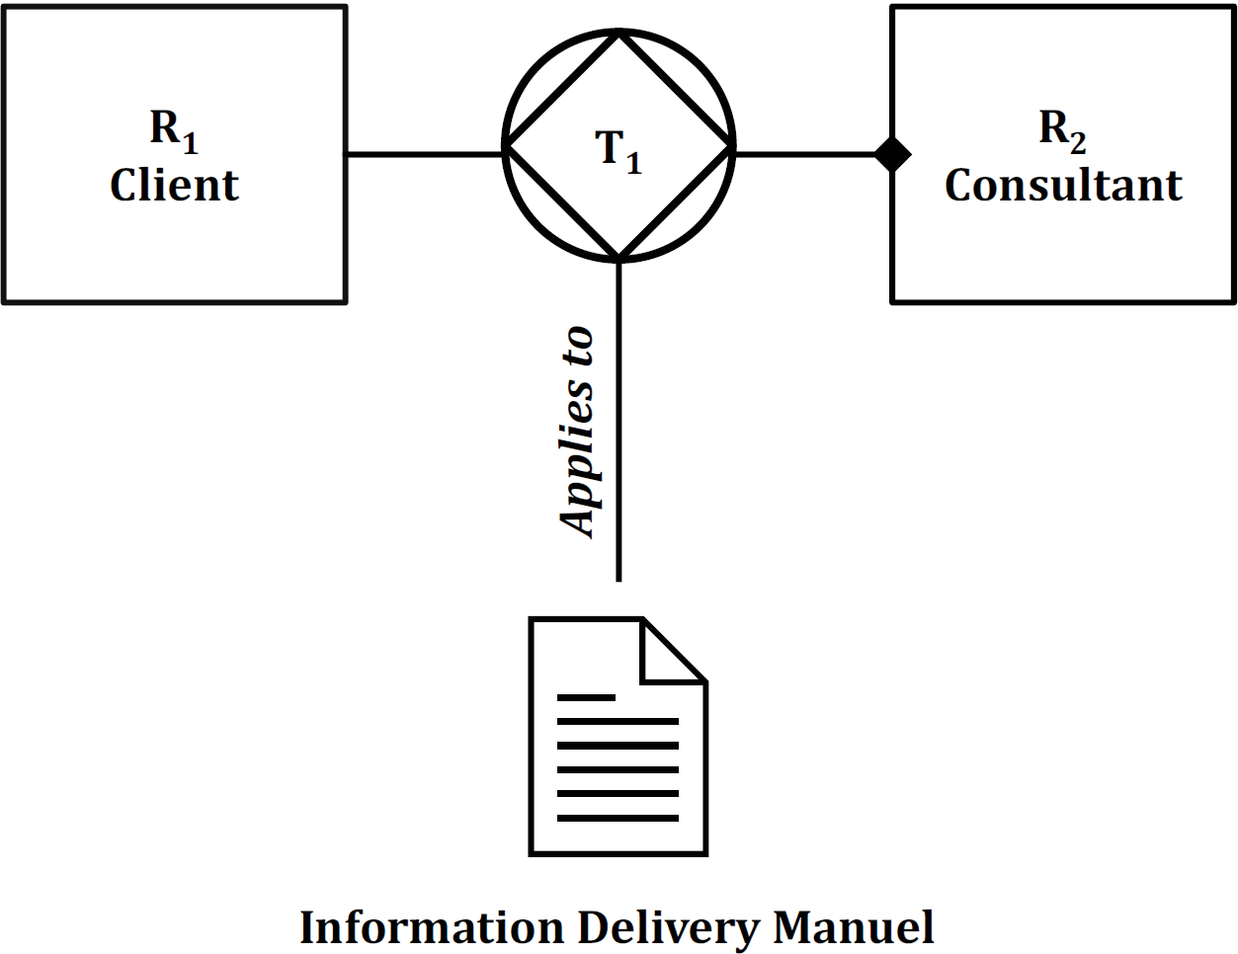

Figure 2 — Example of a simple business context requiring an IDM
When developing an IDM for a given use case from first principles, the nature and context of the information exchange shall be considered through a discovery process. There are two recommended ways of looking at that, each with an associated business context mapping methodology.
— Process maps should be used where the focus is on the business processes (defined by activities executed by actors with roles) that must be followed to deliver a service or produce an end product (such as a design). In this case, the information that is the focus of the IDM is associated with a specific activity within that business process.
— Interaction maps should be used where the focus is on the interactions (made up of a series of transactions) between actors (with roles) who are to deliver a service or product, and the concern is to ensure that agreed communication protocols are in place to ensure that the business goals are achieved. In this case, the information that is the focus of the IDM is associated with a transaction.
These are complementary approaches, so within any given business context, it may be appropriate to use both methodologies: a process map can be used to clarify the details of a transaction identified in an interaction mapping exercise, while an interaction map can be used to rigorously understand an information exchange defined in a process map.
Clauses 4.5.2 and 4.5.3 describe these types of business context maps in greater detail.

Process maps
The process map considers the actor roles involved in the business processes associated with the business context with a focus on the sequence of activities to be undertaken by those actors to support the use case. Information exchanges are identified (giving rise to exchange requirements) where an activity to be performed by one actor requires input from another actor.
A simple example of a process map is provided in the sample IDM referenced in Annex B.
The purpose of a process map is to describe the flow of activities within the boundary of a particular business process, the roles played by the actors involved, together with the information required, consumed and produced.
The approach recommended for representing process maps is the business process modelling notation (BPMN, see the ISO 19510 series). Further guidance on using BPMN is given in Annex C.
Within an IDM, a process map:
— sets the boundary for the extent of the information contained within the business process;
— identifies all the actors involved, assigning each to a swim lane in the diagrammatic representation;
— establishes the activities within the business process;
— shows the logical sequence of the activities;
— supports the expansion of activities with more detailed process maps where appropriate.
The required information associated with a business context is determined by the contents of the exchange requirements specified in the IDM.

Interaction maps
An interaction map is a visual representation of the scope, key roles (actors) and the essential moments of interaction between roles in a business context. Instead of detailing the activities necessary for production or service provision, the interaction map highlights the fundamental transactions—structured interactions—in which actors exchange commitments and coordinate their work.
Each interaction involves a structured conversation between two roles, where a request or delivery of a product or service is agreed. This structured interaction is referred to as a transaction. Each business process is a chain of transactions, each with a defined initiator (the actor responsible for starting the interaction) and an executor (the actor tasked with completing it).
In each transaction, any information exchanges for a specific purpose (e.g. a request for a change or information delivery and the subsequent approval) are identified, governed by specific rules that dictate the sequence of actions. For digital purposes these communicative information exchanges are translated into messages with data forms and attachments that provide the required information to coordinate production or service delivery.
Interaction maps, associated transactions and their message sequence are typically represented as unified modelling language (UML) sequence diagrams. A simple example of an interaction map is provided in the sample IDM referenced in Annex B.
The interaction map and associated transactions form the key components of an interaction framework. ISO 29481-2 specifies a schema for a computer-interpretable interaction framework enabling digital IDM communication for any defined business context. This facilitates (through available software) effective management of the business context to ensure the integrity of any information exchanges and improve the coordination of production and services.
Further guidance on using interaction maps is given in Annex D.
Within an IDM, an interaction map:
— sets the boundary for the extent of the information contained within the business context;
— identifies the actors, either initiators or executors, for each transaction;
— establishes the required interactions within the business process;
— defines the business cooperation and communication requirements allowing the contributions of relevant roles to the information exchanges to be managed;
— supports the detailed expansion of the steps within a transaction to ensure reliable completion.

Exchange requirements
An exchange requirement represents the connection between process and data. It describes a set of information that shall be developed and delivered by an actor to enable a downstream activity to be performed by another actor. It shall be defined with a clear understanding of the information requirements of the downstream actor.

Information delivery
The information delivered in response to defined information requirements is referred to as an information model. This includes both structured information containers (including digital representations of physical assets in the built environment) and unstructured ones such as digital images, drawings and text documents. These may be exchanged as attachments to a digital message or, more commonly, shared as a URL link to one or more information containers held in a shared repository. A set of related information containers may be bundled together into a single file referred to as an information container for linked document delivery (ICDD) as specified in the ISO 21597 series. In addition, information delivery may be facilitated by defining queries against shared databases, whether held within an information model associated with the asset or any accessible private or public database resource relevant to the identified information requirements.
Where an information model that relates to a specific asset is held in a shared repository, it is frequently set up to include information that satisfies many use cases across the full life cycle of that asset. In that case, a specific information exchange may only require a subset of the entire information model, typically specified as an exchange data model (EDM). The implementation of an EDM is further explained in Clause 6.3.

IDM framework

General
An information delivery manual shall comprise the following as shown in Figure 3:
— a description of the addressed use case;
— an analysis of the business context associated with that use case;
— the required information to support the use case defined as one or more exchange requirements.
The business context may be represented in an IDM by any combination of interaction maps and process maps as well as supporting descriptive text and tables. When working from first principles, the analysis of the business context can be thought of as a discovery process using those two mapping approaches since their purpose is to clearly show how the exchange requirements for the use case have been derived. Business context maps shall be used as specified in 5.4.
The required information to support the use case shall be defined in one or more exchange requirements as specified in 5.5.
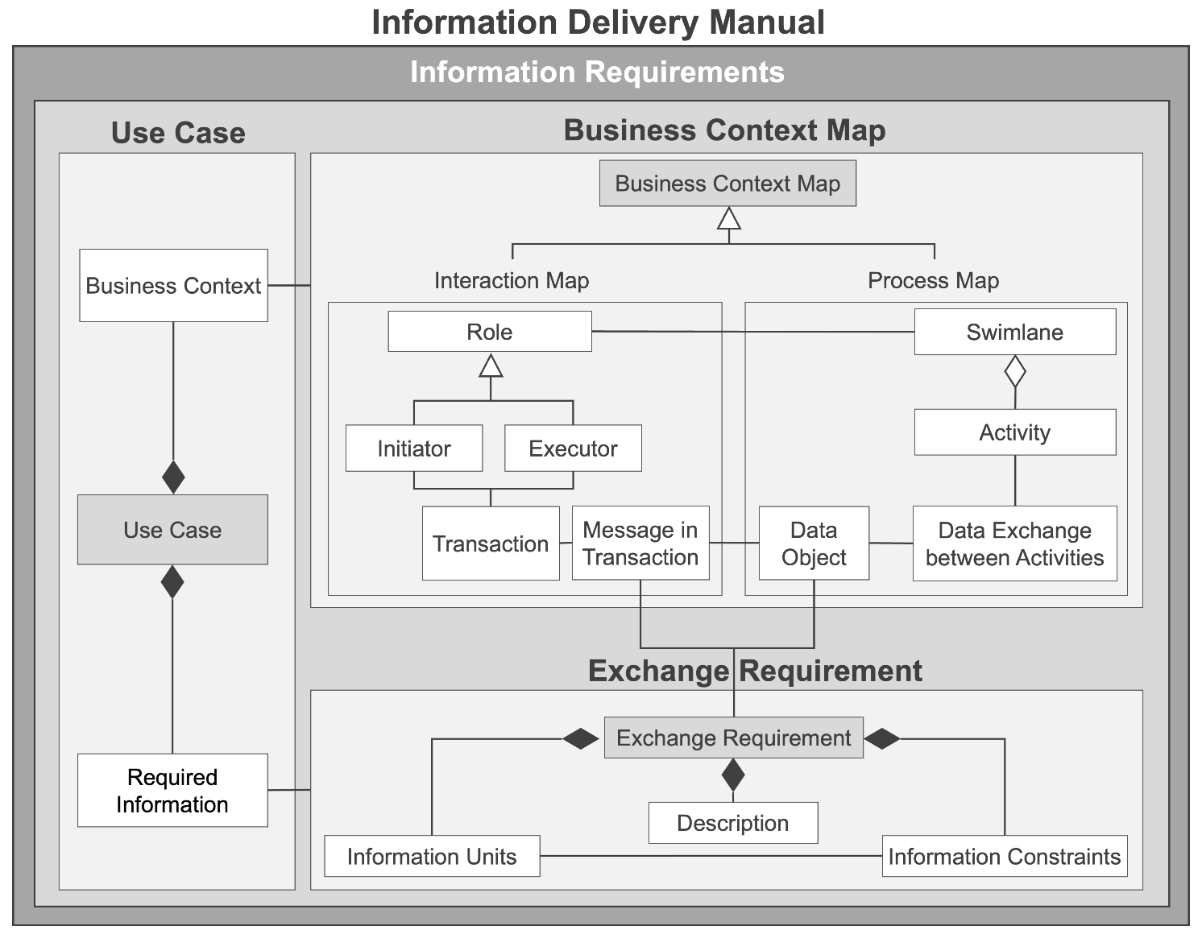
Legend
 | Association
 | Inheritance
 | Aggregation
 | Composition

Figure 3 — IDM basic framework

Common metadata for all IDM components
Each IDM component (use case, business context maps and exchange requirements) shall include common metadata within a header as specified in this subclause. This is illustrated in Figure 4 for the use case component.
The header shall provide at least the following administrative information:
— identifiers including a full title, a short title, and a globally unique identifier;
— authoring information, including authors, a change log that identifies both creation and any change made together with the responsible author and date.
Examples of IDM components are provided in the sample IDM referenced in Annex B.

Use case specification

General
The use case description shall include the header information specified in 5.2 as well as a short overview in the form of a descriptive summary of the contents and purpose of the IDM. In addition, each use case shall state the aim, scope, uses, regional context of the IDM and the relevant standard project phases.
Figure 4 lists the information typically associated with a use case, including optional items that may be included where appropriate.
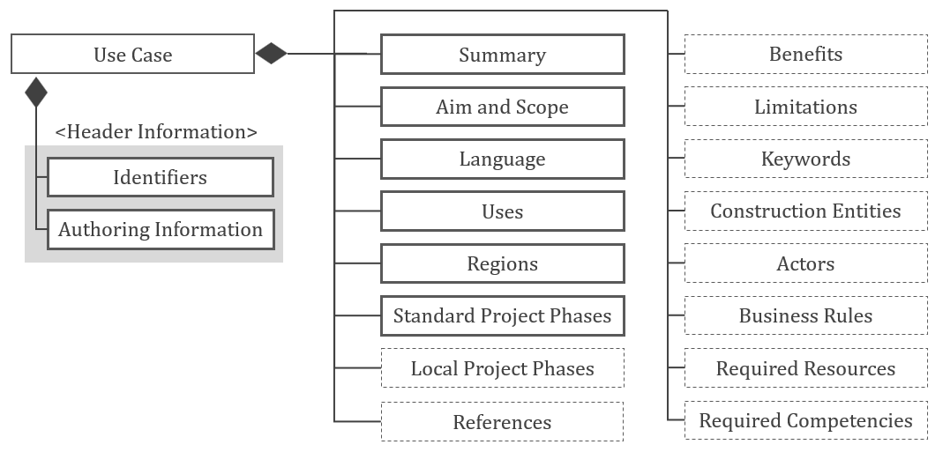

Figure 4 — Typical components of a use case

Standard project phases
Although some exchange requirements are applicable to the entire lifecycle of a project, they are often identified as relevant to particular phases within a project. This document adopts ISO 22263:2008—one of the simplest project lifecycle classification systems—as the basis for providing users of the IDM documents with a common framework for easily searching for, using, and repurposing existing IDM documents related to their projects. The ISO 22263:2008 project phases and their descriptions are listed in Table 1.

Table 1 — Project phases in ISO 22263:2008
ISO 22263  Project Phase | Description
Inception | Establish the need for a project to satisfy the clients business requirement.
Brief | Identify potential solutions to the need and plan for feasibility.  Examine the feasibility of options and decide which of these should be considered for substantive feasibility.  Gain financial approval.
Design | Identify major design elements based on the options presented.  Conceptual design and all deliverables ready for detailed planning approval.  Fix all major design elements to allow the project to proceed.  Gain full financial approval for the project.
Production | Finalize all major deliverables and proceed to construction.  Produce a product that satisfies all client requirements.  Handover the building as planned.
Maintenance | Operate and maintain the product effectively and efficiently.
Demolition | Decommission, dismantle and dispose of the components of the project and the project itself in accordance with environmental and health/safety rules.

Local project phases
The standard project phases may be mapped to project phases commonly used in the target regions. This document refers to the regionally used project phases as local project phrases. Examples of local project phase classification systems include the Royal Institute of British Architects (RIBA) Plan of Work in the UK (see Reference [23]) and the Honorarordnung für Architekten und Ingenieure (HOAI) protocol in Germany (see Reference [22]).
To maintain the integrity of the standard project phases where local project phases are specified in a use case, a direct mapping shall be maintained between those and the local project phases. This is achieved by:
— a direct one-to-one mapping of a standard phase to a phase in the local protocol;
— decomposing a single standard phase into multiple phases in the local protocol;
— mapping multiple standard phases to a single phase in the local protocol.
An example of a mapping table used for this purpose is included in the sample IDM referenced in Annex B.

Business context
An IDM shall include a description of the business context that identifies the need for information exchanges within the business processes associated with the use case. In addition to the required metadata specified in 5.2, the business context may include one or more business context maps (supported by explanatory text where appropriate) that serve to diagrammatically illustrate the business processes.
There are two types of business context maps that are recommended for use both to illustrate the business processes and, when developing an IDM from first principles, to support the discovery process and to understand the information exchanges in those business processes. These are process maps and interaction maps as described in Clause 4.5. They may be used in any combination.
A business context map, where used, shall include the following administrative information:
— the identified exchange requirements that lie within the boundary of the business process;
— an overview that provides a description (including diagrams where appropriate) of the overall business process.

Exchange requirement

General
An exchange requirement defines the information required to be exchanged to support a particular business process at a particular project phase. It provides a description of the information that is understandable to end users (owner, designer, engineer, constructor, etc.).
An exchange requirement shall include at least one information unit as well as the mandatory metadata listed in 5.2, including a name that is indicative of its purpose. It may also include:
— one or more sub exchange requirements;
— descriptive notes that outline its purpose and content.
— information constraints;
— a reference link to external schema elements held in an information model;
Preconditions for the exchange requirement are identified first. A precondition is an exchange requirement that shall be completed prior to the execution of the current exchange requirement.
EXAMPLE: A precondition can state the resources or team member competencies required to perform the activities related to an exchange requirement.

Information units
Each exchange requirement shall be prescribed as a set of information units.
An information unit always deals with one type of information or concept of interest but are typically organised in a nested way in tabular form. For example, an information unit can identify an object in the real world with a required unique identifier (such as a project or a wall) along with information units to capture the required attributes of that object (project name and wall length). Further information units may be specified to capture required information about the component parts of that object.
Information units shall be specified further to provide the following:
— a description of the information unit being as explicit as possible and unambiguous enough not to create confusion with other concepts;
— any special provisions, propositions or rules related to that information.

Information constraints
Information constraints specify the data type of an information unit, and a context, rules, and the restrictions on using the specified information unit. Here are some examples of data types and rules:
— data types;
— text, integer, number, 2D graphic, 3D model, etc.
— context, rules, and the restrictions of use:
— a precast concrete element shall have at least three identifiers: a production serial number, a design number, and an installation location identifier;
— a room serving a given purpose shall not be smaller than 3 m²;
— the largest panel size should not exceed 14 m to permit delivery by a normal truck.

Aspects of technical implementation

General
This document is specifically concerned with the preparation of a natural language description of the exchange requirements of business processes, particularly where those include the exchange of information model data. ISO 29481-3 complements this document by supporting the preparation of an IDM by defining a specification to store, exchange and read IDM specifications that conform to this document in a standardized machine-readable way.
The exchange requirements specified in this document can be used as the basis for automated procedures involving the use of software applications, referred to here as technical implementations.
An overriding intention behind all technical implementations is that the specification shall be converted to a machine-readable form that includes common metadata (see Clause 5.2) required for the automated process.
This clause describes the principles and scope of available technical implementations.

Interaction framework
An interaction framework is a formal schema used for digital IDM communication and contains all the elements of interaction, including definition of roles, transactions, messages in transaction, the sequence of messages, and data elements in messages. The methodology for the development of an interaction framework, its format and how it is used is specified in ISO 29481-2.

Exchange view definition
In this document, the concept of an exchange view and its definition takes on a broad meaning due to the wider application of IDMs to span the full life cycle of an asset (not just its design and construction) and the recognition that the IDM methodology may be applied in many diverse business contexts. Therefore, an EVD shall be understood as a computer interpretable schema that may be used to define a subset of an entire information model (consisting of a set information containers) or a subset of one or more of those information containers.
It is beyond the scope of this document to specify a full EVD schema, but this subclause describes the concept in greater detail with non-specific references to implementations.
An EVD is often used to define a subset of a structured information container that holds a digital representation of a physical asset in the built environment to support one or many specific data exchange requirements. In this subclause, this is referred to as a data model. There are existing software implementations that support that approach for model validation and software certification, but any specification of such implementations is outside the scope of this document.
Typically, an EVD is used to delimit a desired part of a larger data model, or it may describe the entire data model to support the data exchange requirements.
The EVD does not change the types of data components or the data types of attributes of an existing data model, but it may limit the set of values allowed for them. However, if the EVD is used to define a completely new data model, it shall specify the types of data components, the data types of attributes and the allowed sets of values for attributes to be entered as enumerations. Nor does an EVD define the contents of the data components and data fields of the data model, those are included in the information delivery used to fulfil an exchange requirement.
Since the exchange requirement does not specify the data model to be used for information delivery, it follows that when specifying a machine-readable exchange requirement, the data model or the EVD defining the part of the data model that is required shall be specified.
An EVD dedicated to a single IDM can filter data in software tools for a specific exchange requirement. If the exchange requirement and the EVD are presented together, the combination may be used for data validation. Software products that support multiple exchange requirements may implement a consolidated EVD that references multiple IDMs. These EVDs are often used in the certification of software products, but data validation should always be performed for the individual EVD and exchange requirement combination. The EVD specifies what information the exchange should be able to transfer, and the exchange requirement specifies what information should be included.
- (informative)
IDM development guidelines
  - Propose an IDM development
    - General information
A proposal to undertake an IDM development is a preliminary stage that sets the scene for work to be done. It is concerned with:
— considering the use case to define the scope;
— establishing the development approach;
— identifying resources;
— establishing a project plan.
    - Define scope
The scope should set the boundaries for the work that is to be done and provide a continuing reference to ensure that the work boundaries do not grow beyond a point at which the planned or available resources cease to be sufficient.
The following questions should be answered in the preparation:
— What are the business needs for the information exchange?
— Who is able to describe these needs?
— Who are the actors and what are their roles and specialties?
— How can the information exchange be prepared and handled?
— Will existing agreements, contractual conditions, standards, etc. support the information exchange?
The preparation leads to an assessment of whether it is possible to reach the stated scope and success criteria. If the assessment is positive, IDM development may be initiated. If negative, the use case can be revised or the development stopped.
    - Establish the development approach
The development approach selected is determined by the extent of information, software or other exchange requirements available. The approaches are described under A.2.1.
    - Identify resources
Resources are the people who participate in an IDM development. Resources should be properly balanced between project management, development of IDM components and industry knowledge to guide both component development and provision of software solutions. The balance of resources required is affected by the development route that is selected.
    - Activity schedule
The activity schedule sets the period over which the development is to occur, determines the tasks to be undertaken, assigns the available resources and sets the required deliverables.
  - Undertake an IDM development
    - Overview
There are multiple approaches to IDM development. An IDM specification can be developed from first principles or by adopting and modifying a use case (UC), business context maps (BCMs), exchange requirements (ERs), and exchange view definitions (EVDs) drawn from a library of IDM components (Figure A.1). Ideally, IDM specification development begins with UC and BCM specifications followed by an ER specification. Business contexts of a target UC may be illustrated using business context maps such as interaction maps and process maps. However, it is also possible that an ER is defined first and then a UC and business contexts are specified later.
An EVD can be developed from the specified ER by mapping information units in the ER to information elements in a target open data schema such as IFC. Alternatively, if EVDs relevant to the new IDM already exist, one or more EVDs related to the proposed IDM can be used as a good source of ERs.
The development approach is described in Figure A.1 as a linear sequence. In practice, feedback between development stages and cyclic developments can be expected.
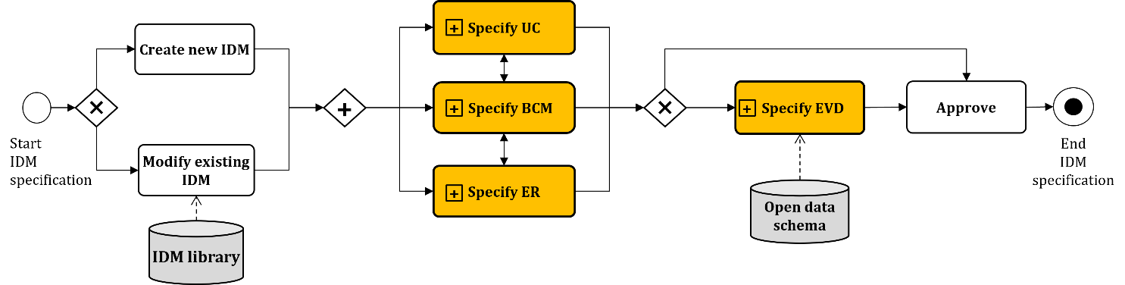

Figure A.1 — IDM development process
    - Discover a use case
The use case discovery process (Figure A.2) aims to identify the scope and context of information required by a project team. This usually requires several cycles of development and review to achieve a satisfactory conclusion. A new UC can be developed either by adopting and modifying an existing UC or working from first principles. A UC can be elaborated by specifying sub-use cases.
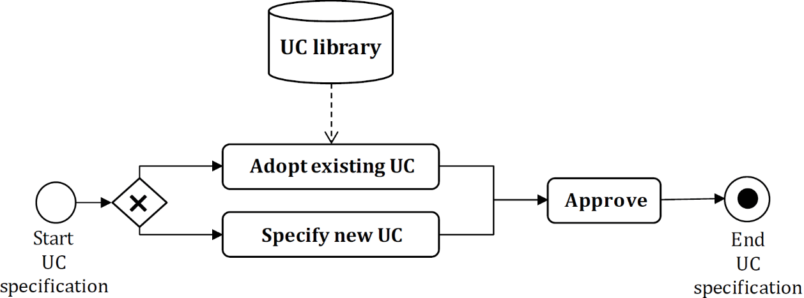
Figure A.2 — UC discovery process
    - Specify business contexts
As part of the IDM discovery process, business contexts of required information exchanges between stakeholders should be represented as business context maps –either process maps (PMs) or interaction maps (IMs), or both – based on the analysis of the UC requirements (Figure A.3). A decision whether to adopt a process that follows existing pratice or a future or better process should be taken as part of the development.
The process maps or interaction maps identify the “packages” of information that must be exchanged at various points in the business process. The “packages” of information give rise to the ERs. The relationships between ERs and specific business contexts in which ERs are exchanged can be represented by linking ERs and the symbols that represent “packages” of information in BCMs (the “data object” in BPMN and the “message” in the interaction framework).
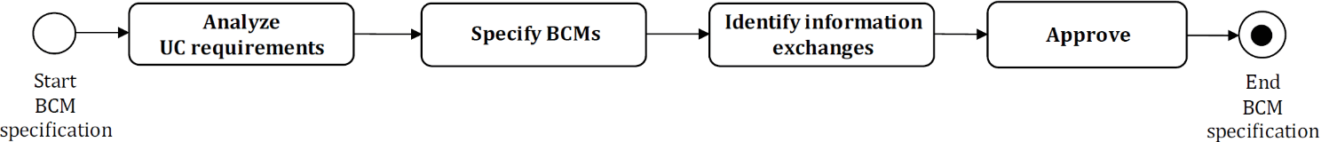

Figure A.3 — BC specification process
    - Create exchange requirement
An ER can be defined from first principles or adopted from an ER library. Multiple ERs can be combined to form a new ER (Figure A.4). An ER can also be developed using existing EVDs as a reference. Alternatively, an existing ER can be broken down into smaller ERs.
The set of information constraints that can be applied to further configure an existing (or newly defined) exchange requirement should be defined. These can be used to control properties to be asserted or values that may be assigned.
Information constraint localization assumes that an exchange requirement exists for the purpose required but that it does not meet the needs for use within a particular administrative context generally linked to a location. Location may be a place (country, region, etc.), a project or a working agreement established between members of a project team.
Information constraints are applied to individual information units within the context of the exchange requirement to make it applicable at a particular location. Note that the same information unit may have different information constraints applied in the context of a different exchange requirement or for a different location.
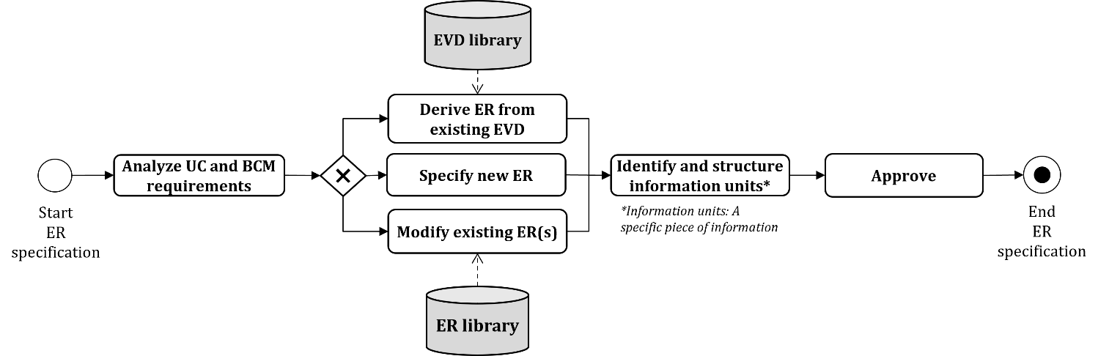

Figure A.4 — ER derivation process
    - Reverse engineering
An IDM is typically developed starting from UC discovery. However, an IDM can be derived from an analysis of information exchanged within an established business workflow. The typical case is when software already exists that is capable of importing the information required to support a particular task, but the specific information items are not clearly documented. This process is referred to as reverse engineering in this document. The typical way of doing reverse engineering is to examine each step in a software tool for achieving a target result and then work through the scenario to identify and specify the data items that are required to support that business process.
    - EVD development process
An EVD can be developed by mapping information units in an ER to information elements in a target open data schema such as IFC (Figure A.5). This mapping process can also be performed through an ontology resource such as the bSDD (buildingSMART data dictionary). The relationships between the EVD elements and the ER information units may be many to many.
If an EVD that supports all or part of the specified use case already exists, information items that are equivalent to the EVD elements can be identified and specified. By undertaking this process, the completeness and appropriateness of the predefined EVD can also be validated.
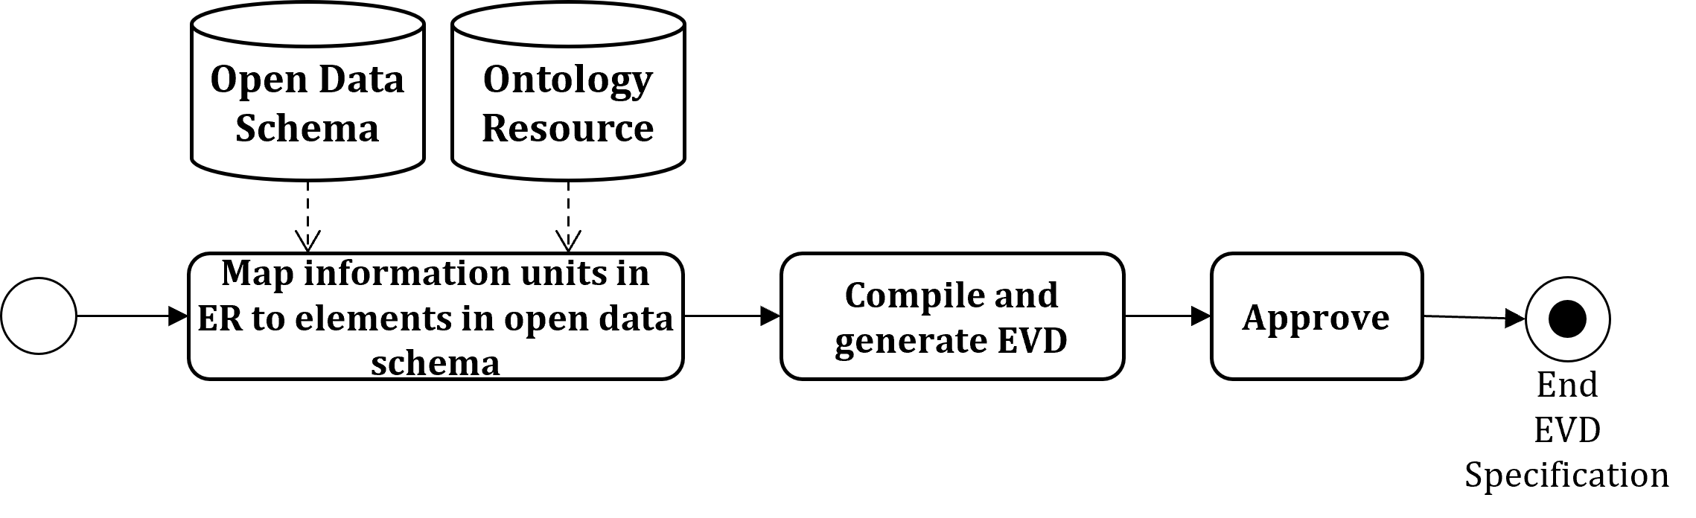

Figure A.5 — EVD development process
    - Validation and use of IDMs
Once the IDM has been prepared and implemented, the information exchange can begin. The exchange should be validated before sending and on receipt.
When the actors have gained adequate information exchange experience, an evaluation can be made. The evaluation covers the preparation, as well as the IDM development and practical implementation issues.
- (informative)
A Simplified Example of an IDM Document
  - General
This annex provides an example of an “IDM for Design Authoring” to illustrate each of the components of an IDM: use case, business context map, and exchange requirement. This example is greatly simplified and is not intended to reflect a real-world application. The example in PDF, XML, and HTML formats can be downloaded from XXX.
- (informative)
IDM use of BPMN methods
  - General information
This document recommends (but does not mandate) the use of the 22 business process modelling notation (BPMN) symbols for the development of process maps (Figure C.1). Table C.1 lists the definitions of the recommended BPMN symbols collected from the BPMN.
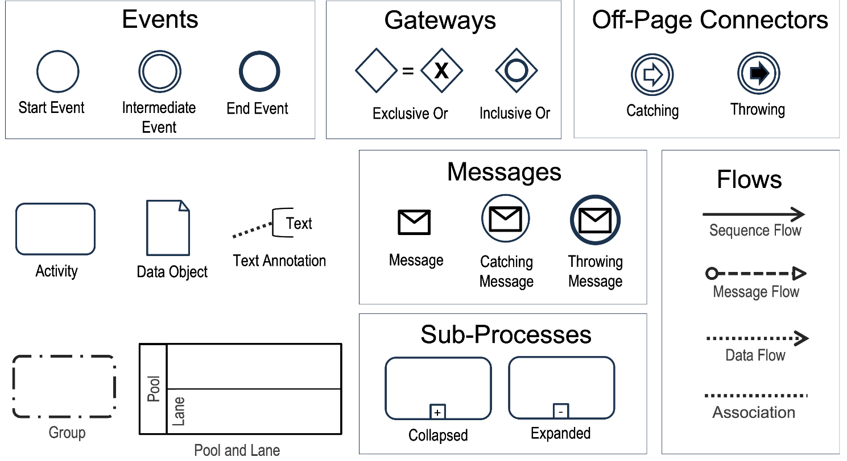
NOTE Source: Reference [19].

Figure C.1 — Recommended subset of BPMN symbols for process map development

Table C.1 — Definitions of the recommended subset of BPMN symbols
Element | Definition
Task | A task is an activity that cannot be broken down within a process.
Sub-process | A sub-process is a compound activity that is included within a process.
Sub-process  (expanded) | The boundary of the sub-process is expanded and the details (a process) are visible within its boundary. Note that sequence flows must not cross the boundary of a sub-process.
Sub-process  (collapsed) | The details of the sub-process are not visible in the diagram. A “plus” sign in the lower-centre of the shape indicates that the activity is a sub-process and has a lower-level of detail.
Start event | A start event indicates where a process will start.
Intermediate event | An intermediate event indicates where something happens somewhere between the start and end of a process.
End event | An end event indicates where a path of a process will end.
Start event (message) | A message arrives from a participant and triggers the start of the process.  The actual participant from which the message is received may be identified by connecting the event to a participant using a message flow within the definitional collaboration of the process.
Intermediate event  (message/catching) | A message intermediate event may be used to either send a message or receive a message. When used to “catch” the message, then the event marker must be unfilled. This causes the process to continue if it was waiting for the message or changes the flow for exception handling.
Intermediate event  (message/throwing) | A message intermediate event may be used to either send a message or receive a message. When used to “throw” the message, the event marker shall be filled (see the upper figure on the right). This causes the process to continue if it was waiting for the message or changes the flow for exception handling.
End event (message) | This type of end indicates that a message is sent to a participant at the conclusion of the process.
Intermediate event  (link/catching) | Paired link events may also be used as “off-page connectors” for printing a process across multiple pages. They may also be used as generic “go to” objects within the process level. There may only be one target link event. When used to “catch” from the source link, the event marker will be unfilled. When used to “throw” to the target link, the event marker will be filled.
Intermediate event
(link/throwing)
Gateway | A gateway is used to control the divergence and convergence of sequence flows in a process and in a choreography. Thus, it will determine branching, forking, merging, and joining of paths. Internal markers will indicate the type of behaviour control.
Gateway (exclusive) | [XOR] when splitting, it routes the sequence flow to exactly one of the outgoing branches. When merging, it awaits one incoming branch to complete before triggering the outgoing flow.
Gateway (parallel) | [AND] when used to split the sequence flow, all outgoing branches are activated simultaneously. When merging parallel branches, it waits for all incoming branches to complete before triggering the outgoing flow.
Gateway (inclusive) | [OR] when splitting, one or more branches are activated. All active incoming branches shall complete before merging.
Sequence flow  (normal or  uncontrolled) | A sequence flow is used to show the order that activities will be performed in a  process.
Message flow | A message flow is used to show the flow of messages between two participants that are prepared to send and receive them. A message flow connects two separate pools. They connect either to the pool boundary or to flow objects within the pool boundary. They must not connect two objects within the same pool.
Association | An association is used to associate information and artefacts with flow objects. Text and graphical non-flow objects may be associated with the flow objects and flow.
Data association | A data association is used to move data between data objects, properties, and inputs and outputs of activities and processes. Data associations may be visually represented in the diagram by using the association connector style.
Pool | A pool is the graphical representation of a participant in a collaboration.  A pool acts as the container for the sequence flows between activities (of a contained process). The sequence flows may cross the boundaries between lanes of a pool but must not cross the boundaries of a pool. That is, a process is fully contained within the pool. The interaction between pools is shown through message flows.
Lane | A lane is a sub-partition within a process (often within a pool) and will extend the entire length of the process level, either vertically or horizontally.  Lanes are often used for such things as internal roles (e.g. manager, associate), systems (e.g. an enterprise application), an internal department (e.g. shipping, finance), etc.
Data object | Data objects are information either as input to or output from activities, or both. Data object elements must be contained within process or sub-process elements. Data objects must not specify states.
Group | A group is not an activity or any flow object, and, therefore, must not connect to sequence flows or message flows. In addition, groups are not constrained by restrictions of pools and lanes.
Text annotation | Text annotations are a mechanism for a modeller to provide additional information for the reader of a BPMN diagram. The text annotation element may be connected to a specific element on the diagram with an association but does not affect the flow of the process.
Clauses C2-C5 are collections of the general principles and rules from the BPMN specification. The Reference [24] can be consulted for examples and details.
  - Specification of flows
In a process map, all of the diagrams and sub-diagrams created for describing the process are included. All processes within the process map have a unique identity and name.
Each process within the process map is described in such detail as required. The aim is to describe the purpose of the process to a reader. The following are the rules specified in the BPMN specification associated with flows.
— Flows
— The arrow shows the direction of the flow, either left to right or top to bottom.
— The sequence flow is contained within the pool and must not cross the boundaries of the pool.
— The interaction between pools is shown through message flows.
— If a sub-process has been expanded within a diagram, the objects within the sub-process must only connect to other objects inside the sub-process.
— Sequence flow connections
— A connecting object that shows the order in which activities are performed in a process and is represented with a solid graphical line.
— Each flow has only one source and only one target.
— A sequence flow may cross the boundaries between lanes of a pool but must remain within the boundaries of a pool.
— Only activities, gateways, and events may be the source and the target.
— Message flow connection
— A message flow is used to connect two separate pools. They connect either to the pool boundary or to flow objects within the pool boundary.
— The interaction between pools is shown through message flows.
— Message flows must only connect to objects that are outside the same pool.
— Only pools (participants), activities, and events may be the source or target of a message flow.
— Association and data association
— Text and graphical non-flow objects may be associated with the flow objects and flow.
— An association is used to connect user-defined text (an annotation) with a flow object.
— A data association uses the same notation as a directed association.
— Data associations are used to move data between data objects, properties, and inputs and outputs of activities, processes.
— Data objects may be directly associated with a sequence flow connector.
— Activities define two sets of data associations, while events define only one.
  - Specification of events
An event indicates the state of an activity. The three basic events are start, intermediate and end events.
Start and end events are as follows.
— A process is instantiated when one of its start events occurs.
— For a process instance to become completed, all tokens in that instance shall reach an end node, i.e. a node without outgoing sequence flows. If a token reaches an end event, the entire process is abnormally terminated.
— The use of start and end events is independent for each level of the diagram.
— If there is a start event, then there must be at least one end event. If there is an end event, then there must be at least one start event.
— If a process requires a trigger message to start, then an explicit start event with a message symbol must be used.
— If a process has a result on completion, then an explicit end event with a message symbol must be used.
— The process must continue until all parallel paths have completed.
  - Specification of data objects
A data object is a named collection of data. It may be a collection of data that is available from an external source (e.g. library data) or it may be data that is exported from an activity to enable other activities to occur (e.g. exchange requirement).
Data objects that are not exchange requirements are given a name that is indicative of their purpose and a description that outlines their purpose and content. The following are the rules specified in the BPMN specification associated with data objects.
— Data object elements must be contained within process or sub-process elements.
— Data associations are always contained within another element that defines when these data associations are going to be executed.
— A data object must be either the source or target of a data flow.
— Data objects may be directly associated with a sequence flow connector.
  - Specification of exchange requirements within a process map
In BPMN models, an exchange requirement is represented using a data object within a process map.
- (informative)
IDM use of interaction map symbols
  - General information
This document recommends the use of the symbols (shown in Figure D.1) for the development of interaction maps. These are drawn from the specification language of design and engineering method for organisations (DEMO) defined in Reference [20]. Table D.1 lists the definitions of the recommended symbols.
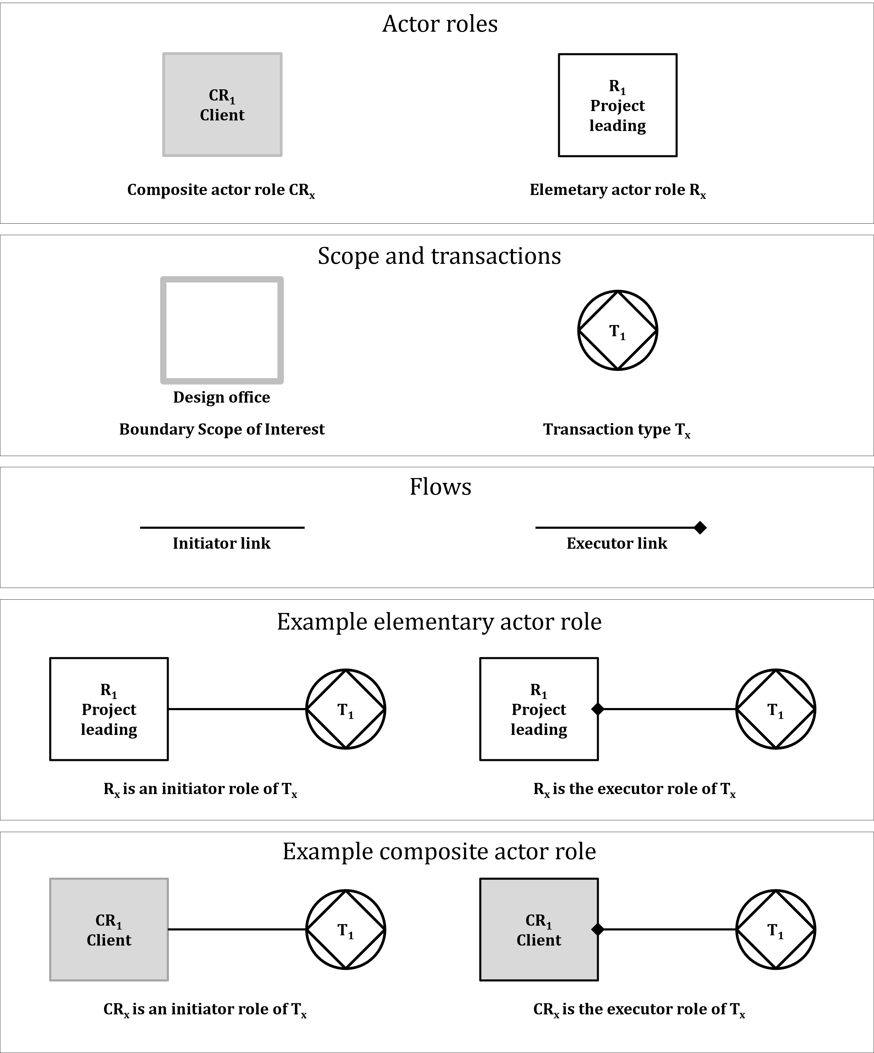

Figure D.1 — Legend of an interaction map
NOTE: The notation used is based on DEMO, but the diagram is referred to as an interaction map to align with the terminology and focus of this document.

Table D.1 — Definitions of the recommended subset of DEMO symbols
Element | Definition
External actor role | An external actor role refers to actors that exist outside the boundary of the scope of interest (SOI) but interact with it. These actors are part of the external context and do not participate in the internal decision-making or operational tasks. However, they play a significant role by providing input (e.g., resources, information) or receiving output (e.g., products, services) from the organization.
Composite actor role | A composite actor role is a role that encompasses several elementary actor roles, functioning as a single, higher-level entity.
Elementary actor role | An elementary actor role refers to an actor without internal subdivisions—meaning the actor is a single entity.
Boundary SOI | The boundary SOI defines the boundaries of the use case within which the organization or system operates. It determines which aspects of the use case are relevant to the model and what is outside its scope.
Transaction type | A transaction type represents a specific kind of interaction that follows the universal transaction pattern.
Initiator link | The initiator link indicates which actor starts a transaction.
Executor link | The executor link shows which actor is responsible for executing the transaction.
  - Specification of transactions and roles
This document uses an interaction map to specify the transactions and actor roles within a use case. The interaction map is based on the essential model concept from the DEMO methodology (Reference [21]), which provides a comprehensive framework for analyzing and designing organizations. The interaction map provides a visual representation of the coordination between actor roles through transactions. In this context, only the essential coordination structure is applied, focusing on the transactions and roles relevant to the defined scope of interest (SOI).
Defining the SOI is the first step in creating an interaction map. Depending on its scope, the map may describe a single use case or several related use cases. It includes all actor roles and transactions necessary to realize coordination within that scope. It is modelled at the required level of detail.
The transactions included in the interaction map are limited to essential transactions, those that lead to the creation or change of what is referred to as unique organizational facts. These can typically be identified in source documentation by verbs such as devising, deciding, judging, paying, manufacturing, transporting, or observing. In contrast, activities such as sending a letter are not considered fact-creating transactions, but may serve as information carriers within essential transactions like deciding or paying.
The following steps provide guidance for creating an interaction map, including commonly applied conventions and structural recommendations.
— Create the interaction map by defining the relevant actor roles and transaction types based on the intended scope of interest (SOI).
— Each actor role and transaction type should have a unique identifier and name to support clarity and traceability.
— Represent all transaction types and actor roles within the chosen SOI by a composite actor role.
— Place border transaction types along the boundary of the SOI. A border transaction kind involves an external actor role as initiator role and an internal actor role as executor role, or vice versa (Figure D.2).
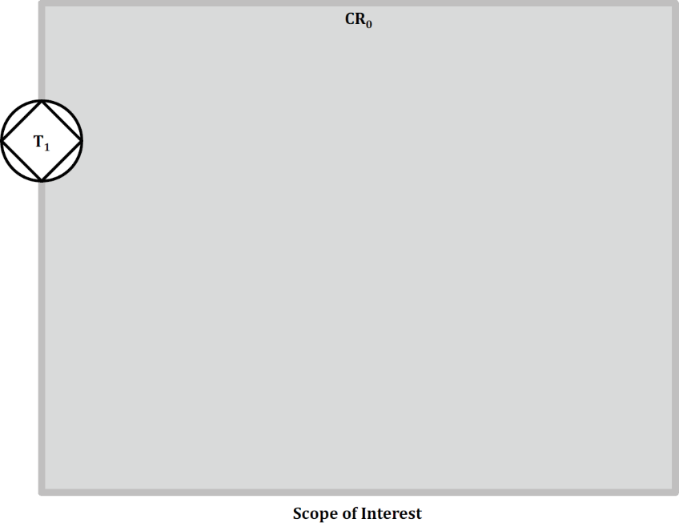

Figure D.2 — SOI as composite actor role and border transaction
— Depict the external actor role outside the SOI boundary and connect it to the border transaction type using an initiator or executor link, depending on its role. Then connect the border transaction type to the composite actor role of the SOI using the corresponding opposite link type (Figure D.3).
NOTE: The external actor role is drawn as an elementary actor role or a composite actor role.
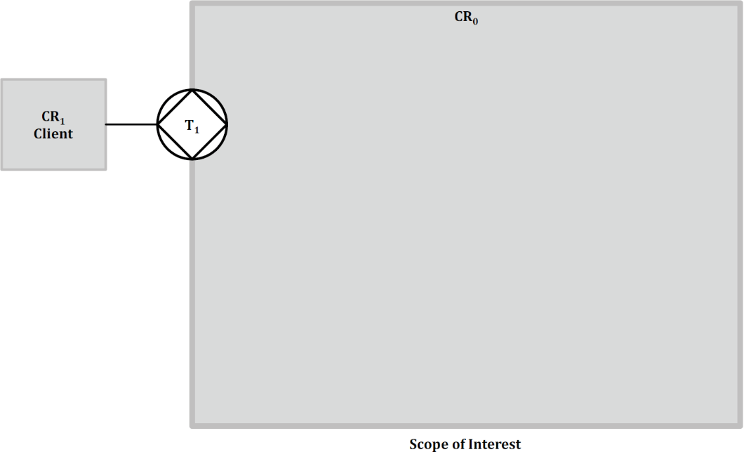

Figure D.3 — External actor role with initiator link to border transaction
— Populate the composite actor role representing the SOI by showing the internal transaction types and their corresponding elementary actor roles within the SOI boundary. Connect the border transaction kinds to the relevant internal roles using the applicable initiator or executor links (Figure D.4).
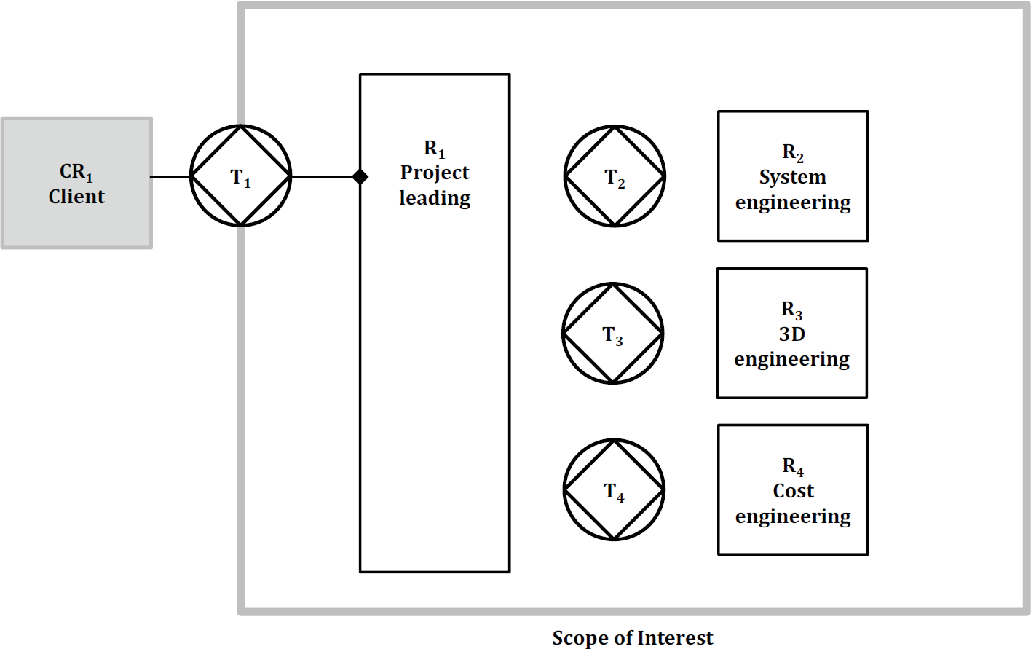

Figure D.4 — External actor role with unveiled SOI
— Connect all internal transaction types to their corresponding elementary actor roles using initiator and executor links(Figure D.5).
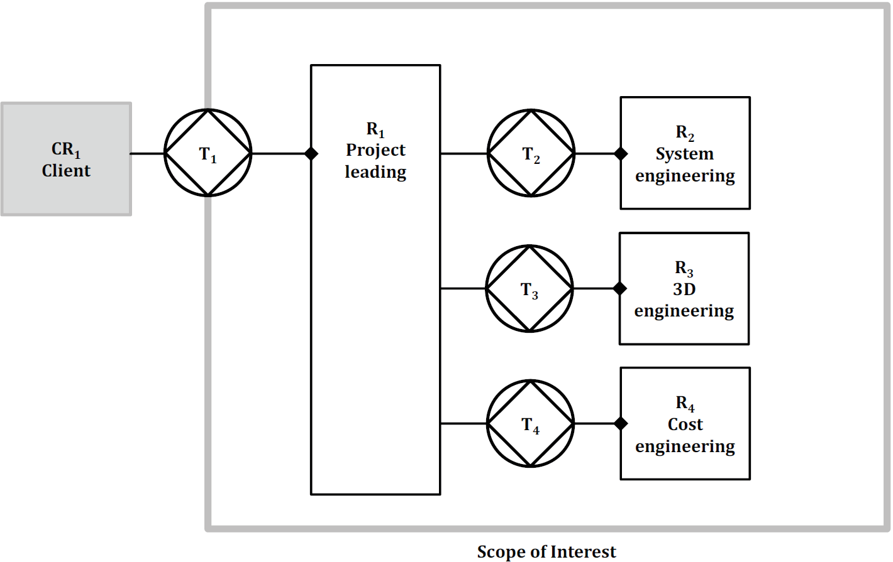

Figure D.5 — Interaction map with all roles linked to transactions
  - Validating the model
Validating an interaction map for a use case involves four claims that should be verified.
— First claim: all identified transaction types in the interaction map do exist in reality.
— Second claim: the identified interaction structure does exist in reality.
— Third claim: the complete transaction pattern can be traversed, for all transaction kinds.
— Fourth claim: the interaction map contains all transactions necessary to produce information requirements within the SOI.
  - Creating a sequence diagram of a transaction
Each transaction within an interaction map can be further specified by defining the specific messages in transaction and their sequence. DEMO states that there is a universal pattern for every transaction, called the standard transaction pattern, however this document allows for free modelling of the sequence of messages within a transaction to support any use case. Each sequence can be described by means of a unified modelling language (UML) sequence diagram. Figure D.6 shows an example of a sequence diagram of transaction T₃: deliver 3D model that is specified in the interaction map depicted in Figure D.5.
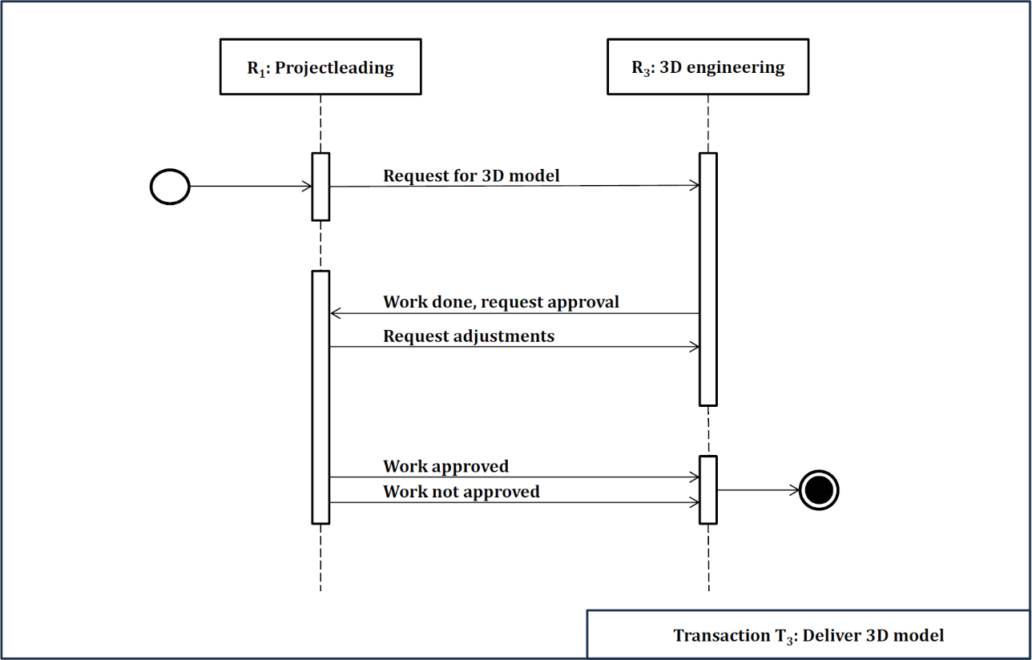

Figure D.6 — Example of a sequence diagram of a transaction

Bibliography
[1] ISO 6707-2:2017, Buildings and civil engineering works — Vocabulary — Part 2: Contract and communication terms
[2] ISO 7817-1, Building information modelling — Level of information need — Part 1: Concepts and principles
[3] ISO 10303 (all parts), Industrial automation systems and integration — Product data representation and exchange
[4] ISO 12006-3, Building construction — Organization of information about construction works — Part 3: Framework for object-oriented information
[5] ISO 12911, Organization and digitization of information about buildings and civil engineering works, including building information modelling (BIM). Framework for specification of BIM implementation
[6] ISO 15836-1:2017, Information and documentation — The Dublin Core metadata element set — Part 1: Core elements
[7] ISO 16739-1, Industry Foundation Classes (IFC) for data sharing in the construction and facility management industries — Part 1: Data schema
[8] ISO 19101-1:2014, Geographic information — Reference model — Part 1: Fundamentals
[9] ISO 19650-1:2018, Organization and digitization of information about buildings and civil engineering works, including building information modelling (BIM) — Information management using building information modelling — Part 1: Concepts and principles
[10] ISO 19650 (all parts), Organization and digitization of information about buildings and civil engineering works, including building information modelling (BIM) — Information management using building information modelling
[11] ISO 21597 (all parts), Information container for linked document delivery — Exchange specification
[12] ISO 22263:2008, Organization of information about construction works — Framework for management of project information
[13] ISO 29481-2, Building information models — Information delivery manual — Part 2: Interaction framework
[14] ISO 29481-3, Building information models — Information delivery manual — Part 3: Data schema
[15] ISO 55000:2024, Asset management — Vocabulary, overview and principles
[16] ISO 9000:2015, Quality management systems — Fundamentals and vocabulary
[17] ISO/IEC 2382:2015, Information technology — Vocabulary
[18] ISO/IEC 19510, Information technology — Object Management Group Business Process Model and Notation
[19] Object Management Group® Standards Development. Organization Business Process Modelling Notation (BPMN), OMG, 2013. Available at: http://www.omg.org/bpmn/
[20] Dietz, J.L.G., Mulder, M.A.T. (2017). DEMO Specification Language 3.7, Enterprise Engineering institute. Available at: https://ee-institute.org/download/demo-specification-language-3-7/
[21] Dietz J.L.G. and Mulder H.B.F. Enterprise Ontology: A Human-Centric Approach to Understanding the Essence of Organisation. Springer; 2 edition, 509 pages, 2024
[22] HOAI. Regulation on Fees for Architectural and Engineering Services (Fee Structure for Architects and Engineers – HOAI 2021). Available at: https://www.hoai.de/hoai/volltext/hoai-2021/
[23] Royal Institute of British Architects. RIBA Plan of Work 2020. Available at: https://www.architecture.com/knowledge-and-resources/resources-landing-page/riba-plan-of-work
[24] Silver, B. BPMN Method and Style: A levels-based methodology for BPM process modelling and improvement using BPMN 2.0, 2011, Cody-Cassidy Press

